

**British Airways Survey Dashboard Report**

**Tools Used:** Tableau,MS Excel,MySql

**1. Introduction**

This report presents an analysis of British Airways customer reviews where data analysis has been done by **MySql** and visualized using a **Tableau dashboard**.

The primary objective is to assess customer satisfaction levels across various service parameters and identify trends based on different factors such as country, and aircraft type.

**2. Excel Data Cleaning & Preparation-**

* Data Source:Kaggle,Countries,csv,BA_reviews.csv
* Raw customer review dataset (CSV/Excel format) including columns like: Review Date, Country, Seat Type, Aircraft, Cabin Staff Service, Entertainment, Food and Beverages, Ground Service, Seat Comfort, Value for Money, Overall Rating
* Key Steps:
* Removed null/missing values.
* Standardized formats (e.g., dates in YYYY-MM-DD).
* Grouped aircraft types and continent mapping.
* Created a clean Excel sheet ready for MySQL import.

**3.** **MySQL: Data Import and Querying**

* Schema used: british_airways
* Table used: ba_reviews
* SQL Tasks Performed:
* Used Table Data Import Wizard in MySQL Workbench.
* Created table schema with appropriate datatypes.
* Key SQL Queries:

#1.Top 5 countries by volume of reviews

select place as country, count(*) as vol_reviews

from ba_reviews

group by place

order by vol_reviews desc;

#2.Average rating by country

select place as country, avg(rating) as avg_rating

from ba_reviews

group by place

order by avg_rating desc;

#3.Top and bottom countries by rating

select place as country,count(*) as num_reviews, avg(rating) from ba_reviews

group by place

order by num_reviews desc;

#4.Average aggregate analysis

SELECT

AVG(rating) AS avg_rating,

AVG(cabin_staff_service),

AVG(entertainment),

AVG(food_beverages),

AVG(ground_service),

AVG(seat_comfort),

AVG(value_for_money)

FROM ba_reviews;

#Aircraft wise analysis

#5.Average rating of aircrafts

SELECT aircraft,

AVG(rating) AS avg_rating

FROM ba_reviews

GROUP BY aircraft

ORDER BY avg_rating DESC;

#6.Total number of reviews per aircraft type

select aircraft,count(*) as total_reviews from ba_reviews

group by aircraft

order by total_reviews desc;

#7.Average rating for all aspects per aircraft

SELECT Aircraft,

AVG(cabin_staff_service) AS Avg_Cabin_Staff,

AVG(entertainment) AS Avg_Entertainment,

AVG(food_beverages) AS Avg_Food,

AVG(ground_service) AS Avg_Ground_Service,

AVG(seat_comfort) AS Avg_Seat_Comfort,

AVG(value_for_money) AS Avg_Value

FROM ba_reviews

GROUP BY Aircraft;

#8.Comparing experiences for different seat types:

SELECT Seat_Type,

AVG(cabin_staff_service) AS Avg_Cabin_Staff,

AVG(entertainment) AS Avg_Entertainment,

AVG(food_beverages) AS Avg_Food,

AVG(ground_service) AS Avg_Ground_Service,

AVG(seat_comfort) AS Avg_Seat_Comfort,

AVG(value_for_money) AS Avg_Value

FROM ba_reviews

GROUP BY Seat_Type;

**4.Tableau Dashboard Overview:**

The dashboard consists of multiple interactive elements, including filters, time-based trends, geographical analysis, and categorical comparisons. Key components include:

* **Key Performance Indicators (KPIs)**

At the top of the dashboard, six KPIs summarize the overall customer ratings for different service aspects:

* **Overall Rating**
* **Cabin Staff Service**
* **Entertainment**
* **Food & Beverages**
* **Ground Service**
* **Seat Comfort**
* **Value for Money**

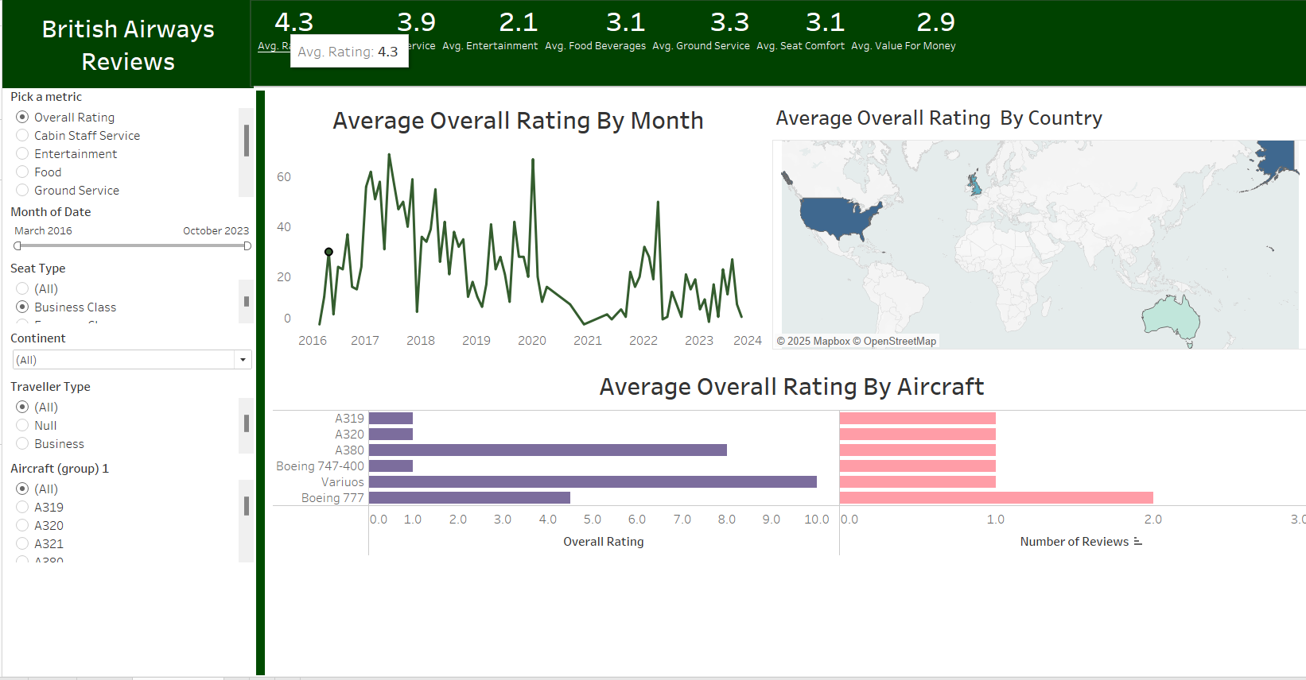

* **Data Visualizations & Analysis**

**3.1 Average Overall Rating by Month**

* This line graph represents the fluctuations in customer ratings from March 2016 to October 2023.
* A significant drop is visible around 2020, likely due to the impact of the COVID-19 pandemic.
* Post-2021, the ratings show a gradual recovery but do not reach pre-pandemic levels.

**3.2 Average Overall Rating by Country**

* A world map highlights the geographical distribution of ratings.
* The United States, the United Kingdom, and Australia appear as major contributors to customer feedback.
* Potential variations in satisfaction levels across countries could be explored further.

**3.3 Average Overall Rating by Aircraft**

* A horizontal bar chart displays the customer ratings for different aircraft models.
* Aircraft such as **A380** and **Boeing 747-400** show higher ratings compared to others.
* **Boeing 777** and some other models have relatively lower ratings.
* **Dashboard Interactivity**

Several filter options are provided on the left panel, allowing users to customize the analysis based on:

* **Service Parameter:** Overall rating, cabin staff service, entertainment, food, ground service.
* **Month of Date:** Selectable date range from March 2016 to October 2023.
* **Seat Type:** Business Class, Economy Class.
* **Continent:** Allows filtering by geographic region.
* **Traveller Type:** Business or leisure.
* **Aircraft Type:** Selection of different aircraft models.

These interactive controls enable a deep dive into customer reviews for better insights.

* **Key Insights:**
* **UK** and **Australia** had the highest number of reviews.
* The average ratings were recorded as- AVG(cabin_staff_service, '2.44'), AVG(entertainment, '0.11'), AVG(food_beverages, '1.88'), AVG(ground_service, , '1.83'), AVG(seat_comfort, '1.88'), AVG(value_for_money, '1.88')
* **A350** and **A320** aircrafts had the highest ratings.
* **Average Entertainment** field recorded the lowest ratings in **Business** class and **Economy** class.
* Customers in first class were satisfied with cabin staff service and food as these were rated as **4.**
* Ratings dipped significantly during COVID-19 (2020–2021).

**6. Conclusion**

This Tableau dashboard effectively visualizes British Airways customer feedback trends across regions, and by aircraft type. The analysis highlights key areas of strength and improvement. By leveraging these insights, British Airways can enhance its service quality and improve overall passenger satisfaction.

**7. Appendix**

* **Data Source:** British Airways customer reviews dataset, Kaggle.
* **Visualization Tool:** Tableau,MySql,Excel
* **Date Range Covered:** March 2016 – October 2023.